MSDS 7330 File Organization and Database Management Mini Project 1 – MySQL

Name: Andrew Abbott

This is a mini project for MSDS 7330, File Organization and Database Management. For this assignment, turn in a single pdf file containing all of your answers. The file should be named ¡yourLastName¿MiniProject-Number.pdf. For example, the file name for my mini project 1 would be ‘RafiqiMiniProject-1.pdf’. Insert your answer pages into this file with the answer for Question 1 inserted immediately after Question 1 and before Question 2, the answer for Question 2 inserted immediately after Question 2, and the answer for Question 3 inserted immediately after Question 3. You may insert a front page containing your name and date if you do not wish to or cannot electronically add that information to the first page of this homework sheet.

Collaboration is expected and encouraged; however, each student must hand in their own homework assignment. To the greatest extent possible, answers should not be copied but, instead, should be written in your own words. Copying answers from anywhere is plagiarism, this includes copying text directly from the textbook. Do not copy answers. Always use your own words and your own code. Directly under each question list all persons with whom you collaborated and list all resources used in arriving at your answer. Resources include but are not limited to the textbook used for this course, papers read on the topic, and Google search results. Don’t forget to place your name on the first page of the pdf document.

# MySQL Database

Question 1 : Download and install the MySQL Community Server database program on your computer. MySQL Community Server is a free download from https://www.mysql.com. If you are running a Microsoft operating system, you may download and install MySQL Workbench as well. If you are using a Mac, you may download the free app Sequel Pro from http://www.sequelpro.com. Both MySQL Workbench and Sequel Pro are visualization applications for accessing MySQL databases.

Once you have installed MySQL, be sure to set the password for your user account on the MySQL database. And, be sure to give your account the privileges needed to create and modify databases. The MySQL reference manual, available from https://www.mysql.com, provides in-depth instructions on how to install and configure your MySQL software.

Once you have installed and configured MySQL, select the mysql database by executing the “USE mysql” command. Then, run the query “SELECT User, Host, Password FROM mysql.user;” from the command line.

Capture the resulting output as a screen capture or grab and turn in the resulting pdf showing both the query and the results.

Collaborators: Andrew Abbott

Resources:

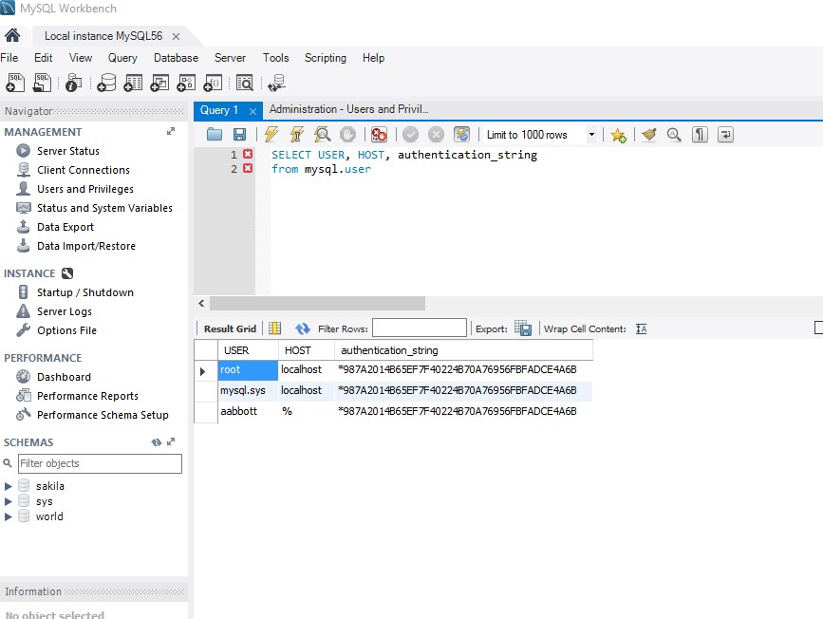

NAME: MSDS 7330 — MINI PROJECT 1 – MYSQL 2

Question 2 :

The file baseball salaries 2003.txt contains salary information for certain professional baseball players from the year 2003. Write a SQL script that processes this file to determine, for each position, the average salary of the players in that position. Note that the seven player positions that can occur in the input file are “Catcher”, “First Baseman”, “Outfielder”, “Pitcher”, “Second Baseman”, “Shortstop” and “Third Baseman”.

Your script should create an appropriate table in your database (you may want to create a new database just for this problem) and populate it using the data in the input file. It should then execute a single SQL query whose output has the schema (position, avgSal). The output should appear sorted in descending order of average salary.

Capture the resulting output as a screen capture or grab. Turn in a pdf of your script and the results.

Collaborators: Andrew Abbott

Resources:

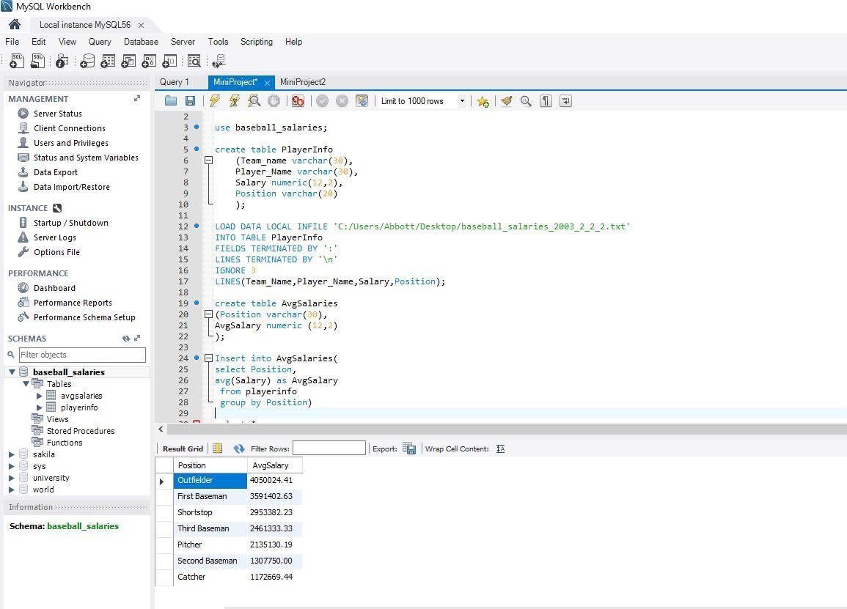

NAME: MSDS 7330 — MINI PROJECT 1 – MYSQL 3

Question 3 :

Create a database called “University”. Load the textbook relations into your *University* database. Access these relations and obtain answers for the following queries:

1. Produce a list of all the students in the student relation, including their ID, name and department name, sorted into ascending order by their name.
2. Produce a list of the names and salaries of professors in the Comp. Sci. and Elec. Eng. departments ordered by decreasing salary.
3. Find all courses whose identifier starts with the string ”CS-1”
4. Find the maximum and minimum enrollment across all sections, considering only sections that had some enrollment, don’t worry about those that had no students taking that section
5. Create a view faculty showing only the ID, name, and department of instructors.
6. Create a view CSinstructors, showing all information about instructors from the Comp. Sci. department.

Capture the sequence of queries and resulting output thereby demonstrating your database in operation. Turn in a pdf of your database in operation.

Collaborators: Andrew Abbott

Resources:

